# Arduino IDE

Written by Mark Webster, Ousema Zayati, and ??

***Summary***

Learn to use the Arduino IDE to develop microcontroller projects.

## Introduction

The software called Arduino Integrated Development Environment (Arduino IDE) is free software from the Arduino organization used to create programs that run on the Arduino family of microcontroller boards, and many other common microcontroller boards as well.

## Download

The Arduino IDE can be obtained from: <https://www.arduino.cc/en/main/software>

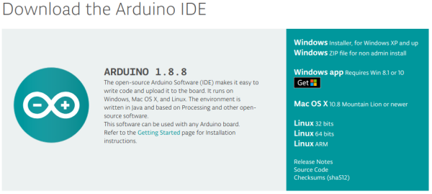

The IDE is cross platform and available on the three main operating systems, Windows, Mac OS X, and Linux. Most computers are 64 bit. Raspberry Pi computers are ARM based.

On Windows the IDE is installed at C:\Program Files (x86)\Arduino\

On Raspbian the IDE is usually installed at: /usr/share/arduino/

On other Linux systems the IDE may be in /opt/arduino/ or /usr/local/arduino/

Generally the full windows IDE is preferred over the Windows app.

The installer should put the files in the correct location. The Arduino sketches (programs) you create are stored in a different spot on the computer, as are the libraries you download. Generally, you don’t need to know where the IDE stores its files. The menu or icon shortcut will have the path to the arduino executable.

The Arduino IDE is written in the Java language which interpreted so it is cross platform for any operating system with a Java Runtime Environment (JRE). That should be installed already with the operating system. Raspbian includes the hard float optimized version of the Java SE Runtime Environment.

If for some reason it isn’t or is corrupt, then download a new version from Oracle. <https://www.java.com/en/download/>

On Linux, the version of the Arduino IDE that is installed by “sudo apt-get install arduino” is usually old. The newest version can be downloaded from the Arduino.cc website. For the Raspberry Pi, download the ARM version. Multiple versions of the Arduino IDE can be installed on the same computer if needed to work with older sketches.

## Sketch and Library Location

The programs created with the Arduino IDE are called sketches, but they are actually C or C++ programs. The file extension is *.ino. The sketch is stored in a directory/folder with the same name as the *.ino file. The arduino sketches and corresponding folders are located in an Arduino folder for newer versions of the IDE.

On the Raspberry Pi for older versions of the Arduino IDE, like 1.6.6, these sketches are in a folder /home/pi/sketchbook. For example, the sketch KeyEcho.ino is located in /home/pi/sketchbook/KeyEcho/KeyEcho.ino. All the user installed libraries on the Raspberry Pi for older versions of the IDE go in the folder /home/pi/sketchbook/libraries.

On Linux, for newer versions of the Arduino IDE, like 1.8.8, the sketches and libraries are installed in a folder called “Arduino” in the user's home directory. For example, for the user “pi” the folder is /home/pi/Arduino/KeyEcho and the libraries are in a folder called “libraries” in the Arduino folder.

On Windows machines the sketches and libraries are in a folder called “Arduino” in the Documents folder. In Windows the Documents folder is in the “My Documents” folder, or for Windows 10 the location is ThisPC -> Documents -> Arduino

A guide to installing libraries is at: <https://www.arduino.cc/en/Guide/Libraries>

## Compile and Upload Code

In the Arduino IDE there are two icons on the top row for compile and upload. The checkmark is compile, the right arrow is upload, the grid is new sketch, the up arrow is open, the down arrow is save.

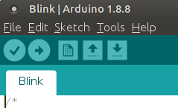

The same commands are available on the Sketch menu. Note the keyboard shortcuts of Ctrl+R, Ctrl+U which are quite handy.

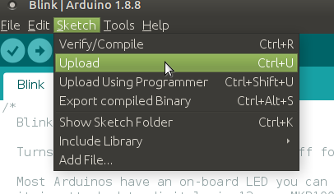

By default, the Upload command also compiles the code.

#### Inline Question: List 3 ways to compile a program

In the black console window at the bottom, there are any compile errors, warnings, and also info on how much memory was used. Since the Arduino Uno only has 32 K of RAM, it is necessary to manage memory usage for larger programs. Just click in the console window and Ctrl+A to select all the comments, then Ctrl+C to copy them. Paste into any text editor to view the messages. Here’s an example of messages for the Blink program. There were no errors.

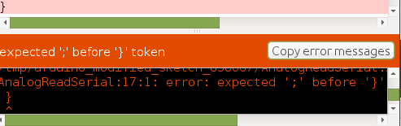

This is the full text pasted into the Pluma text editor. Notice the actual error is a missing semicolon several lines above the last error found by the compiler. It helps to scroll up in the error messages to the first error listed.

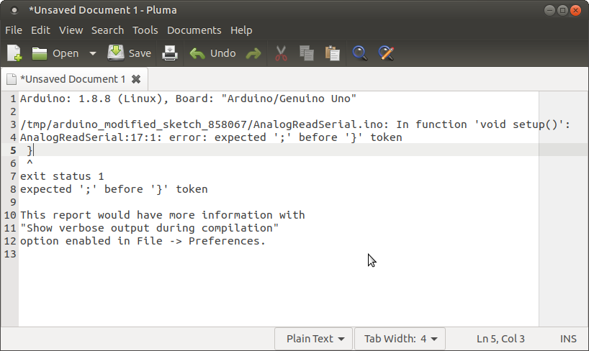

When successfully compiled, the black console window will describe the amount of memory used by each part of the code. The Arduino Uno only has 32K of flash ram so for larger programs this memory usage is critical information.

This BLINK sketch is about as tiny as it gets, and uses 1460 bytes (0%) of program storage space. Maximum is 253952 bytes.

Global variables use 9 bytes (0%) of dynamic memory, leaving 8183 bytes for local variables. Maximum is 8192 bytes.

### Selecting Board and Serial Port

Prior to compiling a new sketch for the first time, one must select the Arduino board to be used and the serial port. The standard boards are listed. Clones use the same settings as the standard board. If additional boards are installed they will show up in the sub-menu.

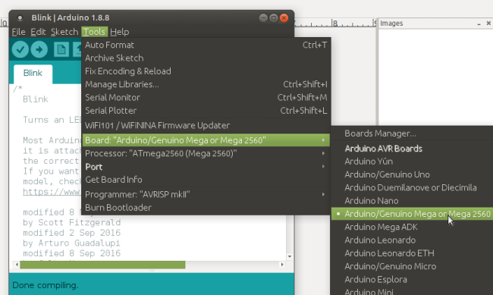

Select the port the Arduino cable is connect to. On Windows serial ports are called “COM1: , COM2:, etc”. On Linux serial ports are files in the “/dev/” directory. If you are unsure which port is used, in a terminal window before plugging in the Arduino to the USB type “ls /dev/tty*” then plug in the Arduino and type “ls /dev/tty*” again. The new entry will be the Arduino. Here’s and example of the terminal screen.

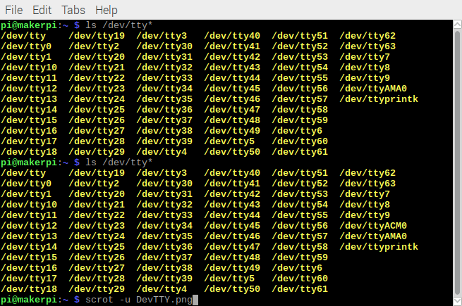

Select the serial port on the Tools -> Port menu.

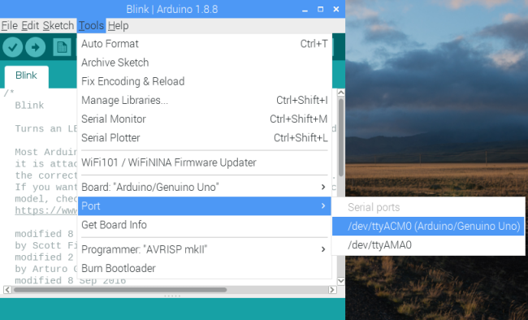

The Mac OS X operating system is a form of Unix, so the serial port can be found the same way as a Raspberry Pi. In a terminal window just type “ls /dev/tty*” before and after plugging in the cable.

Notice the Programmer item on the Tools menu is set to AVRISP mkil. This is the default unless using the Arduino as an ISP to program other microcontrollers.

### Compile

The compilation process is simple for the user, as it was designed to be. Under the hood the IDE does some complicated actions. The complete build process can be found in:

<https://github.com/arduino/Arduino/wiki/Build-Process>

Basically, the *.ino filenames are made into *.cpp, the IDE searches for files in the Arduino application folder, and in the user’s library folder. It also compiles any system files needed in the IDE installation folder. The cross-compilers avr-gcc and avr-g++ invoked. Compiled object *.o files are linked together into a *.hex file which is uploaded to the Arduino board by the software “avrdude”.

Some non-Arduino boards like ESP32 use slow Python code to compile Arduino sketches so the compile and upload process will take much longer than Arduino boards and their clones.

The larger the program, and the larger the included libraries, the longer the compile time.

#### Inline question: Name 3 things the IDE does when a sketch is compiled.

### Upload

The upload button or keyboard shortcut Ctrl+U will compile and upload the sketch to the Arduino board on the specified serial port. If successful the message “Done uploading” will appear. The Arduino board serial TX and RX lights will blink. When done uploading the board will reset and the program will start running. Occasionally the reset fails, especially on other boards like the ESP32, and one must manually press the physical reset button on the board.

If the serial port is messed up somehow, it generate an error message. Sometimes rebooting the computer will reset the serial port. Sometimes the error is real and the board is defective or the cable is defective.

Under the hood, the program “avrdude” is called by the IDE to upload the compiled sketch.

Brave or crazy programmers can call avr-gcc and avr-dude manually within a terminal window and not use the Arduino IDE. There is a tutorial on avrdude at the ladyada website (related to Adafruit devices).

<http://www.ladyada.net/learn/avr/avrdude.html>

## Using Libraries

The Arduino IDE is designed to be as friendly as possible to hobbyist makers. Often this means hiding the messy details of controlling and communication with sensors and electronic modules. The messy details are put in a library that the hobbyist can call without understanding the internals.

A few libraries are built-into the Arduino IDE, most are downloaded from the Internet and installed with the Library Manager.

***Built in libraries***

The built in libraries can be called without downloading and installing anything from the Internet.

Details can be found at:

<https://www.arduino.cc/en/Reference/Libraries>

----Here’s the list of default libraries as of Arduino IDE 1.8.8 --------------

EEPROM - reading and writing to "permanent" storage

Ethernet - for connecting to the internet using the Arduino Ethernet Shield, Arduino Ethernet Shield 2 and Arduino Leonardo ETH

Firmata - for communicating with applications on the computer using a standard serial protocol.

GSM - for connecting to a GSM/GRPS network with the GSM shield.

LiquidCrystal - for controlling liquid crystal displays (LCDs)

SD - for reading and writing SD cards

Servo - for controlling servo motors

SPI - for communicating with devices using the Serial Peripheral Interface (SPI) Bus

SoftwareSerial - for serial communication on any digital pins. Version 1.0 and later of Arduino incorporate Mikal Hart's NewSoftSerial library as SoftwareSerial.

Stepper - for controlling stepper motors

TFT - for drawing text , images, and shapes on the Arduino TFT screen

WiFi - for connecting to the internet using the Arduino WiFi shield

Wire - Two Wire Interface (TWI/I2C) for sending and receiving data over a net of devices or sensors.

***Example code***

Most libraries, even those downloaded from the Internet will contain example programs that are added to the Arduino IDE File-> examples menu toward the bottom. Custom library examples are at the far bottom of the menu. These are valuable to figure out how to use a library.

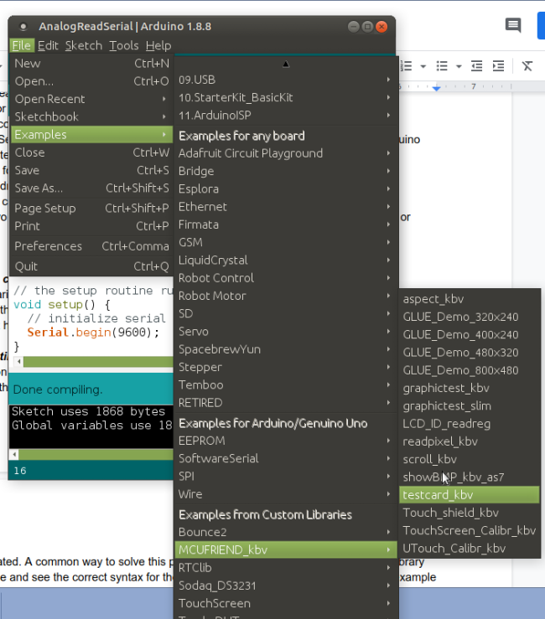

***Incompatibilities***

A common problem with examples or libraries downloaded from the Internet is incompatibility between the library and the example code. The library may have changed since the examples were created. A common way to solve this problem is to look at the source code for the library include file and see the correct syntax for the method calls for that library. Then edit the example code to match the actual library code.

## Library Manager

To install new libraries, they can be copied manually into the libraries folder or preferably, installed using the Library Manager which is on the Tools menu.

To include an already installed library, use the Include Library menu item. This is not needed for standard libraries like <Wire.h>, <Servo.h>, <Stepper.h> which are installed by default.

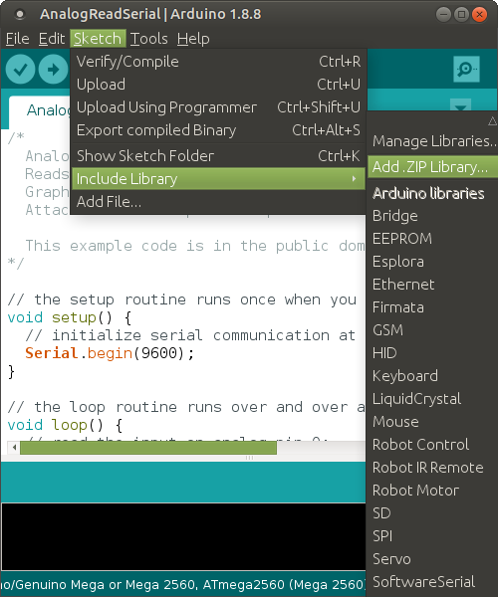

Including the library puts the correct #define <libraryname.h> file at the start of the *.INO sketch. The header file can also be included manually.

If the library is not already installed, there are two choices. First option, go to the Manage Libraries and search for a new library using a keyword.

In the Library Manager dialog, one can search through the existing libraries for a term such as DH11. If the library is not already installed, click on the install button.

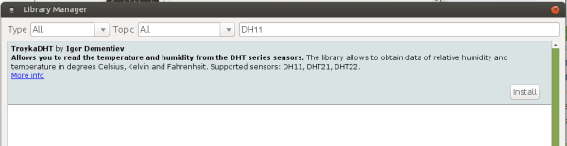

Once installed, the text “INSTALLED” will appear whenever searching for that library. Example code to use that library will also be installed.

The second method is to download a library as a zip file, often from a location such as GitHub.

Here is an example of a DH11 library in GitHub. Click the “Download ZIP” button.

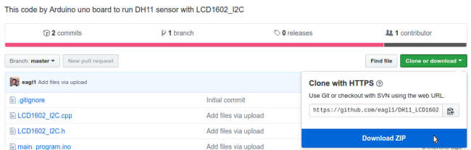

Once the ZIP file is downloaded, go to the Sketch->Include Library->Add .ZIP library option.

Navigate to where the ZIP file is located, select it and click OK

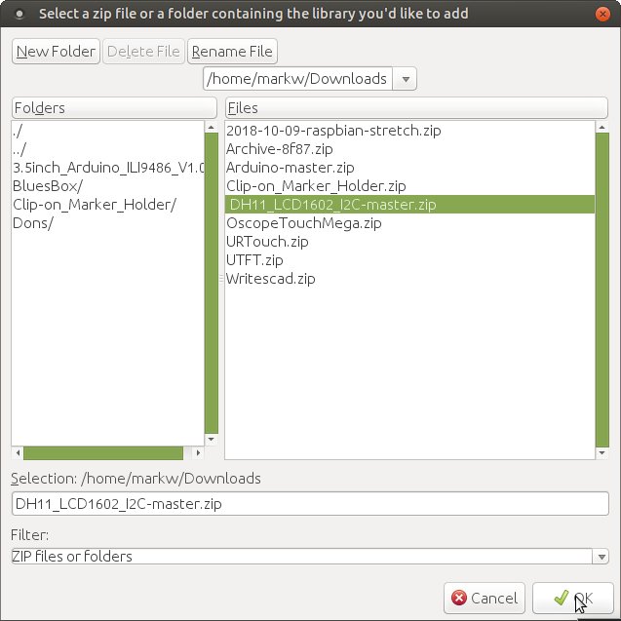

Once the ZIP file is added, then the library can be included from the Sketch->Include Library menu.

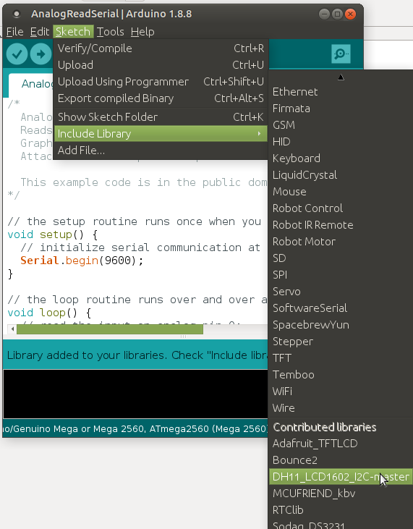

Once a library is included, then it can be referenced inside a sketch using the name

#include <DH11_LCD1602_I2C-master.h>

The actual location of the library is in the libraries folder inside the user’s Arduino folder.

To write your own libraries, review the documentation at:

<https://www.arduino.cc/en/Hacking/libraryTutorial>

There is a style guide for writing <https://www.arduino.cc/en/Reference/APIStyleGuide>

#### Inline question: How to access a library in a sketch?

## Board Manager

Additional non-Arduino boards (called cores) can be programmed using the Arduino IDE.

Details are given at: <https://www.arduino.cc/en/guide/cores>

If a board has been imported already, it can be found in the board manager by searching for that board name. Just click the Install option.

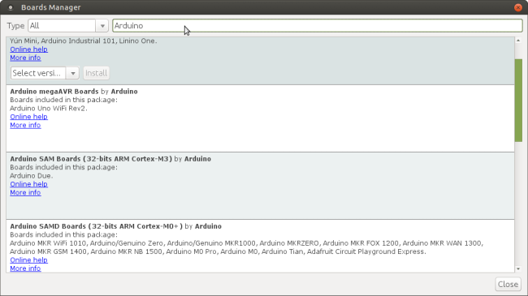

If the board has not been imported, use the Preferences menu Additional board URL. The JSON url is found from the board manufacturer.

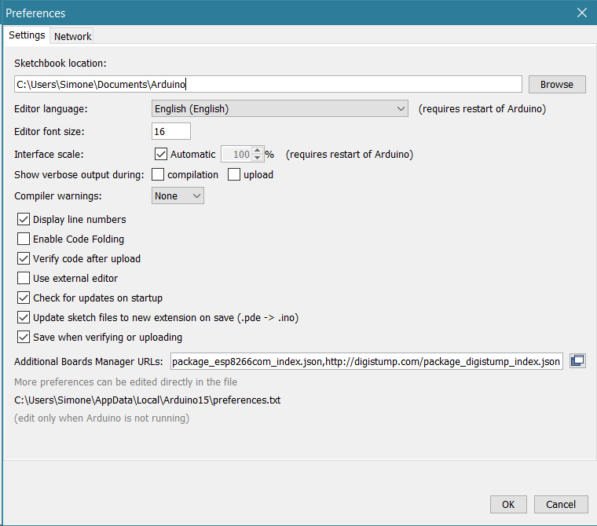

For example, to add the ESP32 board use the URL:

<https://dl.espressif.com/dl/package_esp32_index.json>

To add the ATTiny boards use the URL:

<https://raw.githubusercontent.com/damellis/attiny/ide-1.6.x-boards-manager/package_damellis_attiny_index.json>

To enter multiple JSON URLs click on the icon next to the line with the Additional Board Manager URLs. A dialog box pops up with can support multiple lines of URLs.

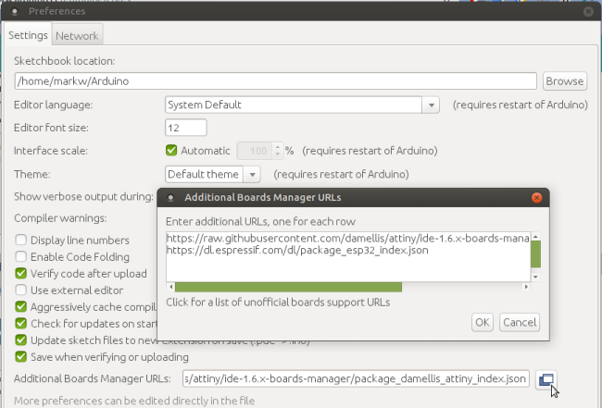

The board can then be installed with the Board Manager.

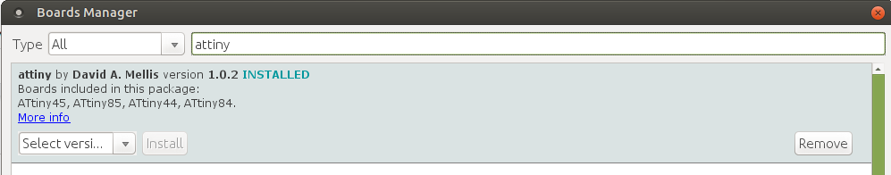

For example, here is the ATTiny board after it is installed.



## Additional C/C++ Code

An Arduino sketch can be broken up into several files. They must all end in *.ino and the main file must have the same name as the sketch directory. Each separate sketch ino file will appear as a different tab in the editor window of the IDE.

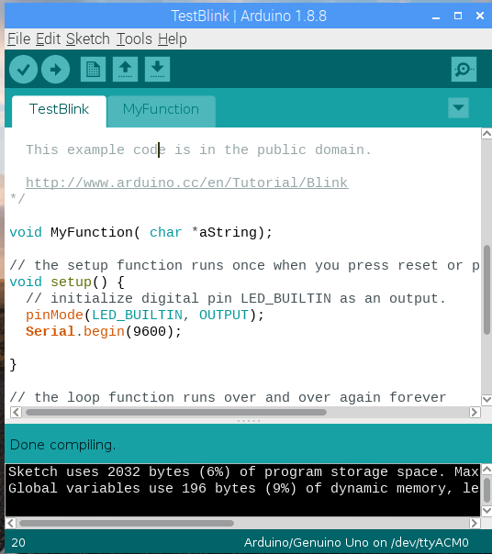

Functions in the second ino file should be declared in the primary ino sketch. The second ino file can reference default objects like Serial that were declared in the primary sketch.

Other C++ files and include files (*.cpp and *.h) generally are made into libraries and #include “mylibrary” is used to include the custom library.

## Debugging

Compile time errors are debugged using messages in the black console window at the bottom of the IDE.

The most common method to debug an executing program is to put Serial.println( a variable) into the code and look at the values in the Serial Monitor. The debug code can be removed later. Sprinkling delay() statements in the code can indicate whether a process was reached or completed.

Code can often be debugged with an online Arduino Simulator. Just search for “online Arduino simulator” for links. An example is <https://circuits.io/>

Microsoft Visual Studio with extensions installed can debug Arduino code, assuming an Arduino is attached.

## Serial Monitor

The serial monitor can be opened from the Tools menu of the IDE.

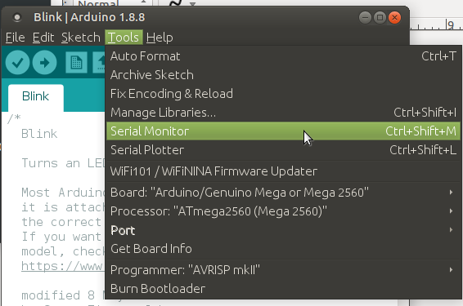

The Serial Monitor window has a text entry box at the top where numbers or letters can be entered and sent to the Arduino board by pressing the Send button. The lower large display area is for text sent back from the Arduino board to the Arduino IDE.

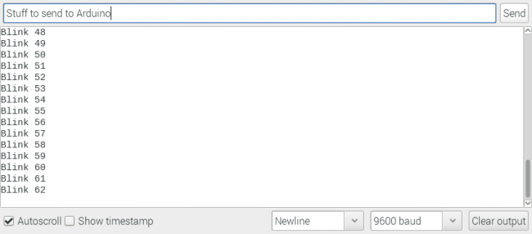

## Serial Plotter

For numeric data sent back from the Arduino board, the values can be graphed with the serial plotter. Open the Serial Plotter from the Tools menu (just below the Serial Monitor). The Serial Plotter automatically rescales the vertical axis which can be both confusing and useful.

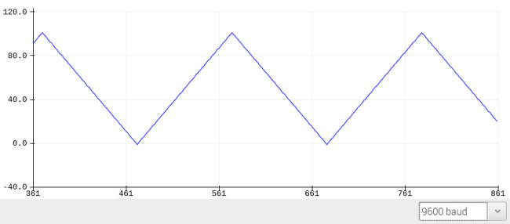

## Arduino as ISP

For programming non-Arduino boards, a regular Arduino board can be used to program the non-Arduino board. Full details are at:

<https://www.arduino.cc/en/tutorial/arduinoISP>

The menu item is Tools -> Programmer -> Arduino as ISP

Normally the programmer is set to AVRISP mkll, and it must be changed.

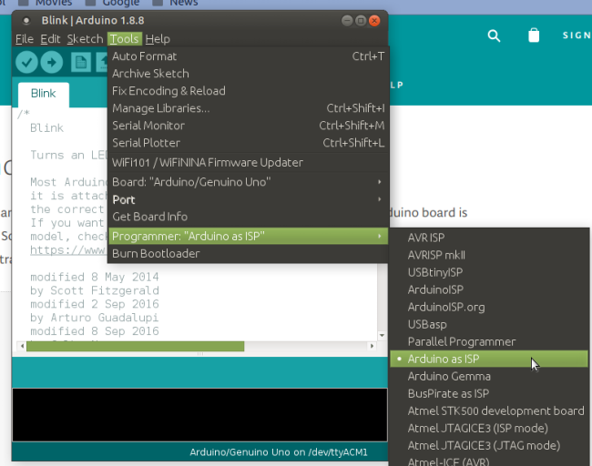

Usually some extra electronics components must be connected to the Arduino to communicate with the other board.

Instead of using an Arduino as an IDE, one can use a FTDI USB breakout connected to the new chip. For example, ATTiny chips do not have a USB connection and must use an ISP or FDTI breakout. Some boards like the ESP32 have a USB connection and don’t need ans ISP.

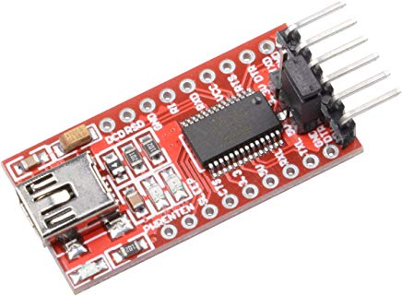

If a person is making their own Arduino board from an ATMEL microcontroller chip, they must burn the Arduino bootloader into the chip. This is also done from the Tools -> Programmer menu.

## Preferences

There are some preferences that can be set from the File -> Preferences dialog.

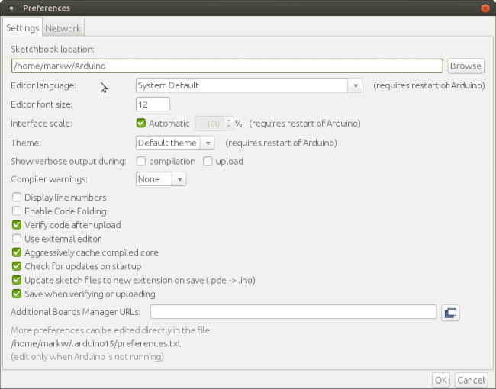

For example, the location of all the Arduino sketches can be changed. The editor font size can be set. The number of compiler warnings can increased. And an external editor can be used with the Arduino IDE.

Adding new boards can be done on this dialog box. For example, for the Expressif ESP32 board, the URL

<https://dl.espressif.com/dl/package_esp32_index.json>

See the Board Manager section of this document for more details.

If an external editor is used, the IDE edit window will be gray and all edits are done in the external editor. The IDE will just be used to compile and upload the code.

## Examples

### Example 1: Change Arduino Uno to Nano

*Hardware*: Arduino Uno, Arduino Nano, USB-A, USB-mini cables

*Software*: Arduino IDE

Find the serial port attached to an Arduino Uno. Write a simple program to blink an LED on pin 12, then run it on the Arduino Uno. You can also edit the BLINK example. Replace the Uno with a Nano (and change the cable from USB-A to USB-mini).

Upload the same program to the Nano. The Nano pins are standard spacing (unlike the Arduino Uno) so it can be put into a regular breakout board.

Note 1: on the Tools menu, change the board. Often the port must be changed as well.

Note 2: Sometimes clone boards like the Nano will use the old bootloader. So if there is an error when uploading select the older processor on the Tools menu.

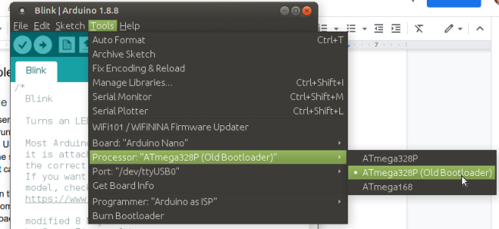

### Example 2: Serial Monitor and Plotter

*Hardware*: breadboard, potentiometer, jumper cables

*Software*: Arduino IDE

Connect a potentiometer to an Arduino Nano A0 analog input. Every 10 milliseconds read the value with analogRead(A0) and write it to the Serial output with Serial.println(). Be sure to initialize the Serial port with Serial.begin() in the loop() section. The AnalogReadSerial example can be edited if desired.

View the output in the Serial Monitor and in the Serial Plotter which are selected from the Tools menu.

Note 1: Sometimes the pins of the Nano must be spread wider to fit into the breadboard.

Note 2: older versions of the Arduino IDE do not have the Serial Plotter.

Note 3: be sure the baud rate is the same for the board, the serial monitor, and the plotter.

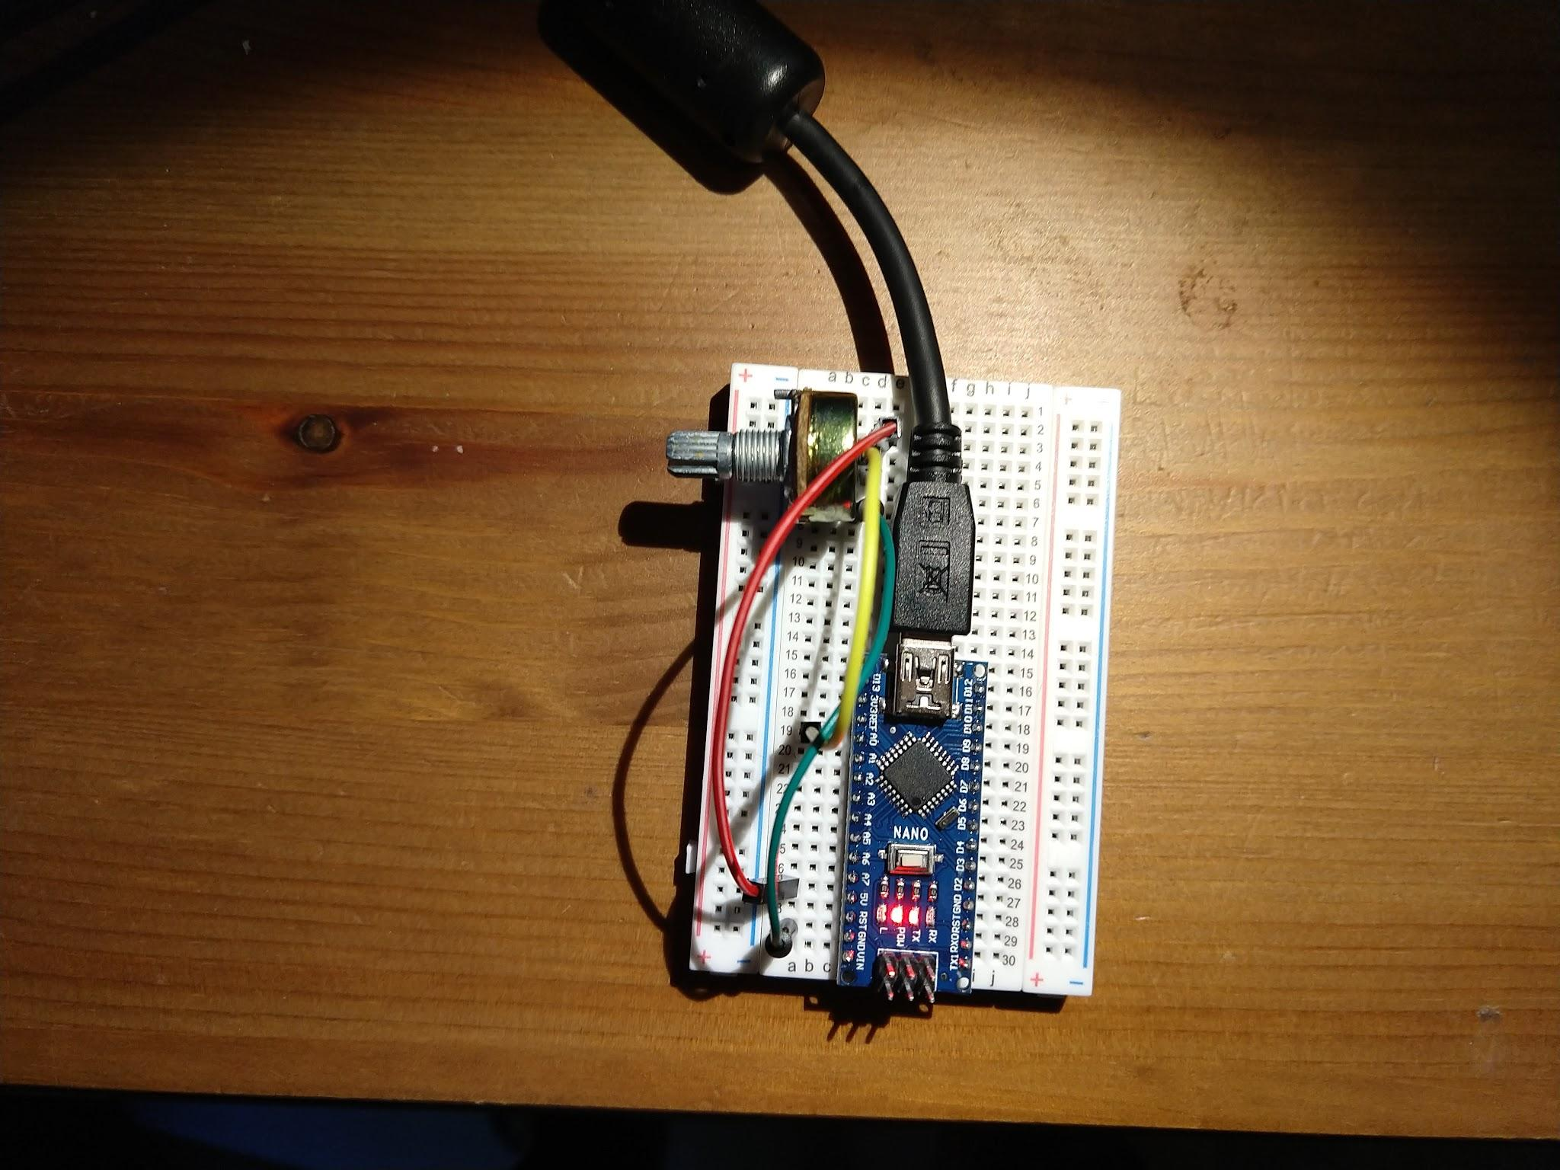

### Example 3: Second INO File

*Hardware*: Arduino Mega, USB-A cable

*Software*: Arduino IDE

Use an Arduino Mega. No special hardware wiring is required. Create a function that writes a numeric value to the Serial output with a label. Put that function in a separate INO file in the same directory as your main Arduino sketch. Call that separate function from the main INO sketch.

Create a new INO file for the new function but save it into the same folder as the main INO sketch. All INO files must be in the same folder. Sometimes it is easier to initially create the second INO file in a text editor outside the IDE.

If the files are in the right location they will appear as separate tabs in the IDE editor.

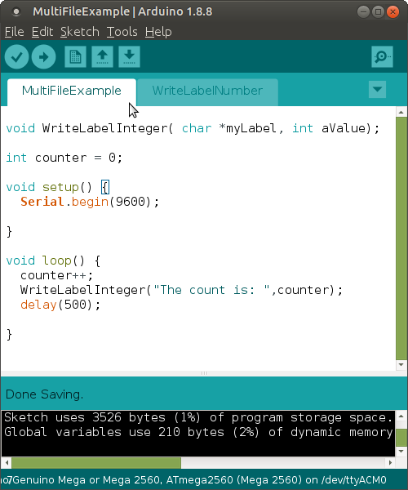

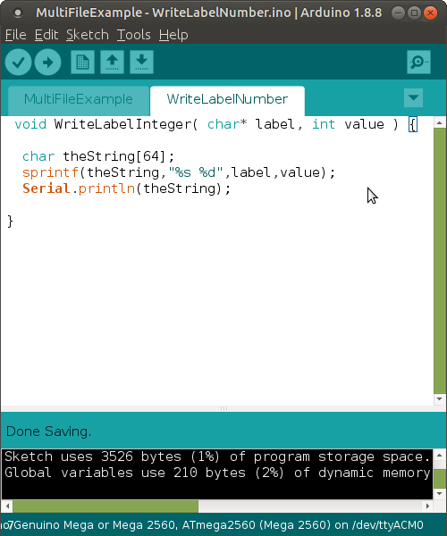

In one file (WriteLabelNumber) put the function:

void WriteLabelInteger( char* label, int value ) {

char theString[64];

sprintf(theString,”%s %d”,label,value);

Serial.println(theString);

}

In the main file (MultiFileExample) declare the function:

void WriteLabelInteger( char *label, int value);

int counter = 0;

setup() {

Serial.begin(9600);

}

loop() {

counter++;

WriteLabelInteger( “The count is: “, counter);

delay(500);

}

View the output with the serial monitor.